**Section 1–1: Patterns and Expressions**

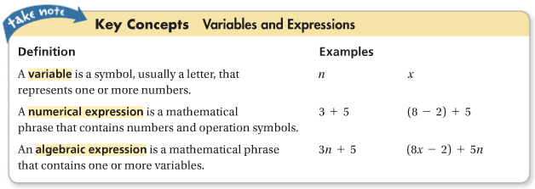

**Example 1: Identifying a Pattern**



By looking at the above pattern, you may or may not immediately know what the next figure looks like. However, you can certainly count each figure and determine how many circles are there.

Figure 1: 1 = 1 Figure 4: 1 + 2 + 3 + 4 = 10

Figure 2: 1 + 2 = 3 Figure 5: 1 + 2 + 3 + 4 + 5 = 15

Figure 3: 1 + 2 + 3 = 6

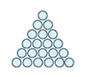

So how many circles will be drawn in Figure 6?

**Figure 6: 1 + 2 + 3 + 4 + 5 + 6 = 21**

**Example 2: Using a Graph**

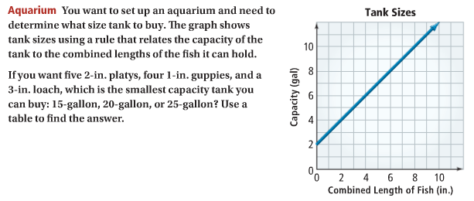

**Step 1:** choose some points on the graph

(0, 2), (4, 6), (7, 9)

**Step 2:** make a table using the input and output values shown in the ordered pairs and find a pattern in the process column

|  |  |  |
| --- | --- | --- |
| Input | Process Column | Output |
| 0 | 0 + 2 | 2 |
| 4 | 4 + 2 | 6 |
| 7 | 7 + 2 | 9 |

**Result:** each output is 2 more than the corresponding input.

You want 5 platys (2-in. each), 4 guppies (1-in. each), and 1 loach (3-in.):

Total Combined Length of the Fishes = 5(2 in.) + 4(1 in.) + 1(3 in.) = 10 in. + 4 in. + 3 in. = **17 in.**

From the process column: output = input + 2

= 17 + 2

= 19

**Conclusion: you will need to buy a 20-gallon tank.**